Github Link: <https://github.com/HaydenDuong/SIT323_Cloud_Native_Application_Development/tree/main/Coding%20Tasks/10.1P>

A/ Tools:

* Node.js
* Docker
* Kubernetes
* Google Cloud Platform Services
  + Artifact Registry Repository
  + VPC Network
  + Google Kubernetes Engine Cluster
  + Logging – Log Explorer

B/ Steps

Accessing the assigned Google Cloud Project by the following steps:

1. Log in Google Cloud via Google Cloud SDK Shell through command “gcloud auth login”.
2. Enter Deakin Email account in the pop-up Google login page.
3. Enter command “gcloud projects list” to check which projects are assigned to the current login accound.
4. Type in “gcloud config set project <project_id>”, in this case, “sit323-25t1-duong-10255c” to switch to that project.
5. (Optional) Re-check the current project by “gcloud config get-value project”.

Create an Artifact Registry Repository (AR Repo) on Google Cloud Platform:

1. Type in Search Box for “Artifact Repository” and enable this API.
2. Choose “Create repository” with the following selections:
   1. Name: “task10-1p-calculator”
   2. Format: “Docker”
   3. Mode: “Standard”
   4. Location Type: “Region”
      1. Region: “australia-southeast2 (Melbourne)”
   5. Leave other selections as their initial state and click “Create” button.

1. Grant the push-pull image from AR Repo to Docker by type in command:

“gcloud auth configure-docker <Region_selected>-docker.pkg.dev”

1. Build a Docker image for the application through Dockerfile with its name matching the criteria for pushing to Docker Hub:

“docker build <docker-hub_username>/<image_name>:<version>”

“docker build hayden2310/task10-p-calculator:v1”

1. Push this image to Docker Hub through command: “docker push <image_name>:<version>
2. Create a new image from this image through the following command:

“docker tag <image_name> <region_selected>-docker.pkg.dev/<project_id>/<AR_Repo_name>/<image_name>:<tag>”

1. This newly created image is now push-able to AR Repo as its name has meet the requirement through command “docker push <image_name>

Create Google Kubernetes Engine (GKE) Cluster

1. Create a VPC network through command in Google Cloud Shell:

“gcloud compute networks create gke-network –subnet-mode=auto”

1. Enable Kubernetes Engine API on Google Cloud Platform.
2. Create a cluster with the following:
   1. Switch to: “Standard Cluster”
   2. Name: “task10-1p-cluster-standard”
   3. Region: “australia-southeast2”
   4. Cluster tier: “Standard tier”
   5. In “default-pool”: Number of nodes = “1”
   6. Choose “Create” button

1. Enter this command into Google Cloud Shell:

gcloud container clusters get-credentials task10-1p-cluster-standard --region australia-southeast2 --project sit323-25t1-duong-102550c



1. Check status:

Create Deployment.yaml & Service.yaml for the application:

1. Deployment.yaml:

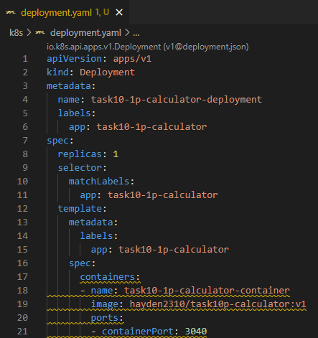

1. Service.yaml:

1. Apply these two YAML files and check their status:

1. Testing the web application through the external ip

Setup the Monitoring in GCP

* Have to unclicked “Active” for these two metrics to be found:
  + kubernetes.io/container/cpu/request_utilization
  + kubernetes.io/container/memory/request_utilization

* For both metric, add as following images

* Navigate to “Logging”-“Logs explorer”
* Apply the following:

Result:

C/ Challenges

* There was no network available for the creation of GKE cluster.
  + Manually created a VPC network called “gke network” by using command “gcloud compute networks create gke-network –subnet-mode=auto”
  + With this network, GKE cluster can now use it for create.
* Autopilot GKE cluster did not generate any node to be used for deployment with k8s.
  + Had to switched to Standard Cluster Mode and and set the number of nodes to “1”
  + 3 nodes were created and now be able to used for deployment
* Artifact Registry Repository does not allow image pulling from it to the local for deployment
  + Had to pull image from Docker Hub through fixing the image name in deployment.yaml
* From Microsoft Team, I found that some students are experiencing with no-shown metric on GCP platform, as result, I decided to use results generated from kubectl to substituate through command “kubectl top nodes” and “kubectl top pods” to display the percentage usage of CPU & Memory, as well as, the unit they are using in “cores” and “bytes”, correspondingly.

